**• Certainty Predicting Memory •**

**Coding Manual**

BACKGROUND & PURPOSE:

The purpose of this coding manual will be to help you, and another independent coder to reach the same conclusions when scoring participant free-recall text.

You will be scoring the free-recall text based on preservation of temporal order.

By comparing the free recall text and the objective video annotations using these two measures, you will be able to score the temporal accuracy of each participant’s free recall

*Preservation of Temporal Order:*

* The accuracy of the text in reference to the sequence of scenes recalled from the video stimulus. Simply put, how accurate were the participants in remembering the scenes in the same order they were shown in video?

CHECKLIST:

* Watch the stimulus video (“StimVidTestFirstHalf” and “StimVidTestLastHalf”)
  + This will help you understand the content and order of the video, and make it easier to parse through the free-recall text
* Write short summaries for each scene (refer to “StimVid-Timestamps” for start and end of each scene, and read the video annotations
  + This will help you further solidify the specific events in each scene and understand each scene. Participant transcripts might talk about these scenes using different words, so it’s important to have a thorough understanding of each scene to recognize what the participant is saying.
* Code 1 participant on your own
* Attend Coder Meeting w/ Caroline and Billy to discuss discrepancies and confusions
* Code 5 more participants on your own
* Conduct ICC test to establish reliability (ICC value = at least 0.85)
* Continue coding the rest of the transcripts!

CODING TEMPORAL ORDER:

For each participant transcript, identify these things:

* What event are they describing?
  + This is the most important thing! Even if the other two
* Which characters are they talking about?
* Which pieces of dialogue do they discuss?

Knowing these three things will help you understand which scene the participant is talking about. This will help you determine the overall order of scenes in the transcript

Then, break down the transcript into the different scenes that you think the participant is recounting and mark the temporal order:

1. Read through the transcript.
2. Identify which scene the participant is recounting (refer to the timestamps and video annotations).
3. Copy this section of the transcript and paste it into the cell corresponding to the participant in the spreadsheet. In the cell next to it, write the number of the scene that the participant described.
4. In the end, you should have a list of the order of scenes *as the participant remembered.*

**1**

**2**

**5**

**4**

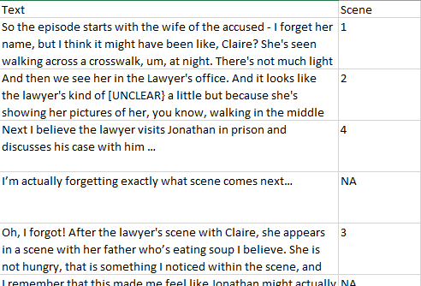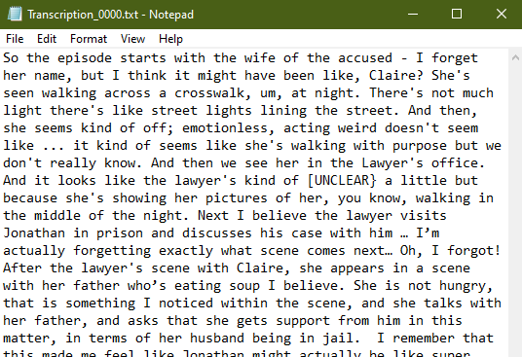

**Fig. Transcription Example.** A **transcription file** is systematically converted into a **scene progression document**, right. Notice that text is broken into chunks (Stylized in colored highlighter above) and copied verbatim to the scene progression document. Each chunk should describe a single scene. Once the transcription description starts describing details of a new scene (**1**), a new chunk begins. The scene number designated by the annotations guide that you believe matches the description gets placed in the Scene Column (**2**). In some cases, participants may describe scenes out of order, either describing a scene too early in the chronological order (**3**), or going back to describe a scene they forgot(**4**). Between scene descriptions, participants may also say things that aren’t related to any scene. Denote these with an **NA** (**5**). Every piece of text from the **transcription file** should be transferred to the **scene progression document** by the time you are done.

**3**